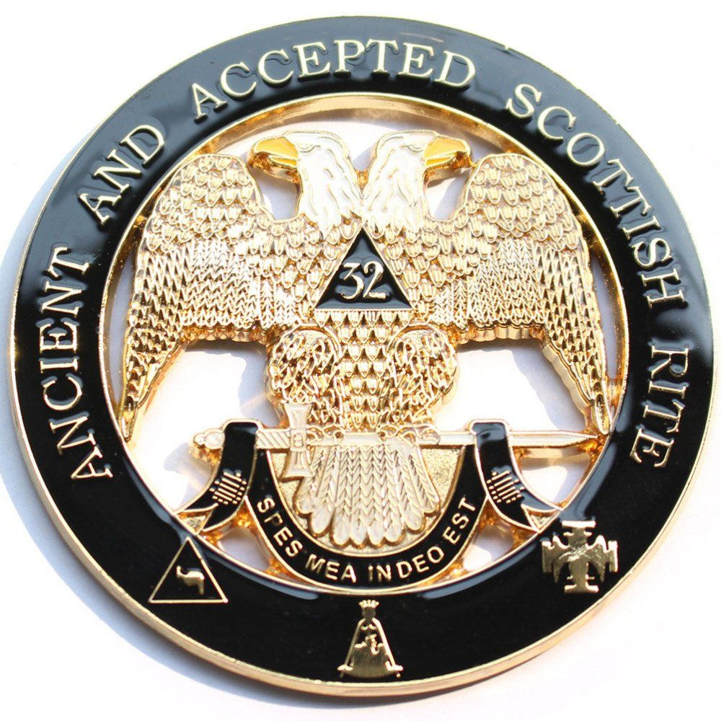**101st Scottish Rite Conference of Virginia**

**Portsmouth Valley**

**P.O. Box 7276**

**Portsmouth, VA 23707**

**Holiday Inn Hotel and Conference Center**

**5655 Greenwich Road, Virginia Beach, VA 23462**

**25 – 27 September 2025**

Brethren and Ladies,

I am very excited about the upcoming 101st annual meeting of the Scottish Rite Conference of Virginia, and would like to extend a personal invitation to you. It will be held at the Holiday Inn Hotel and Conference Center, 5655 Greenwich Road, Virginia Beach, VA 23462 on 25th - 27th September 2025.

We have a lot to offer at this year’s conference, starting with a Top Golf outing on Thursday evening, the 25th. From 6 – 9pm, join us for an evening of fun, games, food and camaraderie. Top Golf is a golf-based fun center that requires no golfing skills, just an opportunity for a good time and lots of laughs!

Friday, the 26th, a conference kick-off lunch will be served in the main hospitality room, followed by two outstanding educational sessions, and a few breakout meetings to follow them. Friday evening will be the Rite Care Banquet, with a focus and program on our favorite Scottish Rite Philanthropy.

Saturday, the 27th, our business session of our conference will be held in the morning. The ladies will have an opportunity to visit the Glass Studio of the Chrysler Museum in Norfolk, to enjoy a catered brunch, followed by a glass-blowing demonstration. This has received very good reviews and I’m sure our ladies will also enjoy it.

Also, Saturday afternoon will feature the Investiture of the Knight Commander of the Court of Honor (KCCH) to be performed at Princess Anne Masonic Lodge by the very capable investiture team from Norfolk Valley.

Saturday night will culminate with the Conference Banquet, with local favorites “Strolling Strings” providing a very melodic, enjoyable dining atmosphere. We are very pleased to have our Deputy Grand Master, RW “Matt” Szramoski as the keynote speaker.

Hospitality rooms will be open in the evenings, following the banquets.

I hope you will consider joining us for this year’s 101st annual conference and enjoying fellowship, food, and fun with us!!

Sincerely and fraternally,

Randall D. “Randy” Reed

President